Project 3:

Requirements & Design

Simplified Sckhaedgeuler (SS)

Snow College

*Generation of the Requirements and Begin Design of the System*

Leedan Johnson, Alex Thayn, Jackson Porter

Table of Contents

**Current System Concept Statement** **4**

**Scope of Our Project** **4**

**Design Requirements** **5**

**Models and Rationale** **11**

**User Models** **13**

User Classes 13

Work Roles 13

Primary Roles 13

Sub-Roles 14

Mediated Roles 14

Personas 15

Social Model 17

**Usage/Flow Model** **18**

Hierarchical Task Inventory Diagram 19

Usage Scenarios 20

Usage Scenario about a group of students using the “as is” system: 20

Envisioned Usage scenario for Simplified Sckhaedgeuler 22

**Work Environment Models** **23**

Artifact Model 23

# 

# 

# 

# 

# Current System Concept Statement

The Simplified Sckhaedgeuler (SS) provides simple and efficient room scheduling for large organizations. SS is easy to learn, and easier to use. With online access through our web portal, users are able to manage reservations throughout campus. Existing room schedulers and building administrators will be allowed to retain whatever measure of control they desire, or they can let SS handle it autonomously. Users will love the many built-in smart features, including email confirmations and reminders. Feedback and maintenance is also handled effortlessly, allowing users to report issues with reservations which will be instantly made known to management, and other room reservees. In short, the Simplified Sckhaedgeuler overcomes the challenges of traditional room management, allowing the process to be effortless and enjoyable.

# Scope of Our Project

We began to trim and tailor our scope within this phase of the project. During our interview with the registrar and assistant registrar we realized a need to include the ability to schedule not only events, but also classes. During our various interviews we also found the need for a central scheduler and would like to include that in the scope of our project.

The scope of our project will include a central scheduler who has complete control of the system and various sub-users of the system. We would like to have the current building manager retain some control over their building, but trim down their access according to their needs and the needs of the central scheduler. We would also like to provide access for faculty and students to be able to schedule certain rooms through a web page. We have not included the ability for outside business to schedule rooms within our scope because we found this is a rare occurrence.

# Design Requirements

How we extracted requirements

From the WAAD, specific representative data items were selected, and using deductive reasoning, product requirements were derived. This worked very well, but the rigidity of this process can overcomplicate requirement extraction, especially when the person explicitly states a requirement.

|  |
| --- |
| **Notifications**  **Our solution will include email or text communication with the user, and thereby send reminders about reservations, as well as notifications if the status of a room is changed, or issues are reported in the feedback.**    *[I1 08:27] A reminder about the reservation would be nice, so I don’t forget. A* text *message or something like that.*  *[W 12:48] I would like notifications if the status of a room’s attributes have changed.*  Emails and Text Messages are common forms of reminders/notifications. The customer here states that they would like a reminder about the reservation. We can conclude that our solution should include email or text communication with the user, and thereby send reminders about reservations.  Because we are already employing email and/or text message notifications, and the user wants to be notified of changes in the room attributes, **we will ensure that the user is notified via email or text when any changes are made to a room’s current status, or feedback is given reporting problems with the room or any of its equipment.** |
| **Low-Cost**  **We will develop a low-cost solution, that we can market at a competitive price.**    *[I2 26:15] We are a small institution, we try and keep our costs low.*    In order to keep its costs low, an institution needs to keep its expenses down. Therefore, **we should strive to develop a low-cost solution, that we can market at a competitive price.** |
| **Room Details/Feedback**  **We will include a room details page which includes what equipment the room has. Our solution will allow room users to easily give feedback about any problems with the room or it’s equipment, and we will cause that the room details page is instantly updated with any problems noted in the feedback.**  *[W 07:54] I want the room description to be kept up-to-date with what is broken, such as technology that has been complained about or issues with the room.*  Details about the room would logically be shown before the reservation is made. The people most likely to notice problems with the room are those who use it. The status of the room could change quickly. Therefore, we should include a room details page which includes what equipment the room has. **We should allow room users to easily give feedback about any problems with the room or it’s equipment, and we should keep the room details page updated with any problems noted in the feedback.** |
| **Scalability**  **We will focus on scalability during development, and ensure our solution is efficient and lightweight.**    *[I1 12:54] Then that system would need to be very scalable to. Have to scale it very easily to incorporate new buildings.*    Because the system we produce will need to scale, **we should focus on scalability during development, and ensure our solution is efficient and lightweight.** |
| **Recurring reservations/Fast reservations**  **Our system will be able to create recurring reservations, and make reservations quickly.**    *[I1 06:22] When it's worked at its best we reserved a room for a meeting in the horseshoe room last year and we just went in and talked to whoever is in charge of scheduling at the GSC and they put us down every week at a certain time and we never had any conflicts. It only took about 2 minutes, no issues.*  Because this was an example of success with the given system, we want to implement those things that made it successful. **We will allow our system to create recurring reservations, and make reservations quickly.** |
| **Prioritization**  **Each reservation will be given a priority level, and allow higher-priority reservations take precedence.**    *[I2 14:59] Academic classes have priority for scheduling.*    Because academic oriented reservations should take priority, **we will make sure each reservation is given a priority level, and allow higher-priority reservations take precedence.** |
| **Manager Access**  **Our scheduler will allow for “Managers” to see everything as it happens, and have the choice to let the software handle the reservations, or give the manager the ability to approve/reject reservations for any, or all rooms under their jurisdiction.**    *[I2 18:53] It very hard to change because everyone has ownership in the part of campus that they are scheduling and it would be hard for them to give up their power. They feel responsibility for it and feel like they can take care of it better than a central scheduler.*    Because users may resist relinquishing power, we can conclude that allowing them to retain some measure of control would appeal to them, and ease the transition. **Our scheduler will allow for “Managers” to see everything as it happens, and have the choice to let the software handle the reservations, or give the manager the ability to approve/reject reservations for any, or all rooms under their jurisdiction.** |
| **Simplicity**  **Our software interface will be simple and intuitive.**  *[I2 29:15] Most of the software that’s out there for scheduling, you have to do a lot of training on.*  Because complex software requires a great deal of training, and the user would prefer to avoid training, **we will keep our software user interface as simple and intuitive as possible.** |
| **Reservations**  **Our system will create a reservation record that will be used to manage rooms.**  *[I1 01:26] The current system is somewhat effective because you can get the room reserved, and you hopefully won’t get kicked out if you have a reservation.*  Because our software needs to create reservations, **we will create a reservation record to track reservations made using our software.** |
| **Unity/Consistency**  **Our scheduler will have a single point of access. User and administrator views will be similar.**    *[I1 16:30] I want a uniform and consistent interface so the experience is the same wherever you access the system.*  Because the user wants a consistent interface, **we will try to minimize and unify points of access, and keep the interface for users and administrators as similar as possible.** |
| **No Native Outside Business Support**  **Our software will not include native support for reservations made by outside entities.**  *[I2 09:17] We don’t have a ton of outside businesses coming in to use our rooms.*  Because few outside businesses frequently make room reservations, **we will not handle that specific scenario.** |
| **Web Access**  **Our solution will be used by clients and managers through a web portal.**    *[I1 22:58] I think there should be a website available so we can make reservations from anywhere.*    Because most if not all of our target users will have access to the internet, and all administrators will have internet access, **we will use a web portal as our solution’s point of access.** |
| **Public Vacancy List**  **Our scheduler will have a live viewable vacancy list for each room.**  *[I2 21:45] I would like to see a vacancy list that anyone can view.*  Because users of our system will need to see vacancies before reserving a room, **we will include a live display of vacancies viewable by all users.** |
| **Optional Hidden Details**  **We will provide the option for any reservation to have its details hidden, and the room simply seen as ‘reserved’ by other users.**    *[I2 23:18] We live in the world of protecting privacy, the federal privacy act of 1974, so every time something happens we’re stopping to ask “Is this going to violate anyone’s privacy?”*  Because of the potential issues due to privacy concerns, and because the institution is bound by the federal privacy act, **we will provide the option for any reservation to have its details hidden, and the room simply seen as ‘reserved’ by other users.** |

# 

# 

# 

# 

# 

# Models and Rationale

**User Classes:** We identified user classes to see where our work roles intersect and what class of users our system needs to cater to.

**Work roles:** We wanted to determine our work roles for this system to gain a better understanding of who was involved with the scheduling system.

**Personas:** For many of the work roles we identified, we decided to create a persona that further explains the work role we are trying to understand.

**Social Model:** The social model shows the different social interactions within the workplace and outside the workplace. This diagram shows the feelings and the concerns of all involved with this new system, SS.

**Flow Model:** In order to show the “flow” or the interaction and order of things when using our software. It shows what person is allowed what access, etc. It shows the systematic process between people and system.

**Hierarchical Task Inventory Diagram:** We created this diagram to identify tasks involved with each work roles. This will help guide our design process by ensuring we are designing our system to be able to do the tasks needed by each user.

**Usage Scenarios:** The construction of usage scenarios helped us identify barriers within the current system that we needed to address within the design phase.

**Artifact Model:** The system we will be implementing will consist of several disparate parts that must communicate effectively. The artifact model allows us to see the associations between these parts, and identify further potential barriers.

**Omitted Models:** There were a few types of models that we did not include as we felt we were able to express our points with the above mentioned models. Some of the models that we did not include were a Physical Model (Work Environment Model) and an Information Object Model. If you look at the models that we included, you can see a full picture and story of the usage and the design of our software.

# User Models

## User Classes

* **Managers:** These people are highly trained individuals who work with the system on a daily basis. They have varying level of administrative abilities. The goal of a scheduling manager is to maintain control of the various rooms available to reserve and make sure user’s needs are met.
* **Event/Reservation Creators:** These people are users of the system and may or may not have a familiarity with the technology. Their goals is to create a room reservation according to their needs.

## Work Roles

### Primary Roles

* **Reservees/System Users:** Includes all those who will use the system to make a reservation*(Has Sub-roles)*.
* **Managers:** All those who are given jurisdiction over any portion of a building, building, or group of buildings*(Has sub-roles)*.
* **Administrator:** A single highly trained individual, with full access to the entire system. This individual controls the level of access for all other system users.

### Sub-Roles

* **Registrar(Manager):** The registrar is an experienced user and is in charge of scheduling classes throughout campus. This person has a high level of access for scheduling classrooms.
* **Building Manager(Manager):** The building manager will maintain a certain level of control over their building as needed. They are able to view scheduled rooms, remove user access to certain rooms, deal with problems associated with rooms, and remove certain reservations.
* **Faculty(System User):** The faculty members of Snow College will have general computer skills. They Will use the web page to reserve rooms for classes, class activities, and events.
* **Students(System User):** The students of Snow College will be another group of users of the scheduling system and also have varying levels of computer skills. They would like to reserve rooms through the web page for club meetings, study groups, etc.

### Mediated Roles

* **Outside Businesses:** Not included in our scope. These users will be routed through a manager or the administrator, who will make the reservation on their behalf.

## PersonasUserPersona - Administrator.jpg

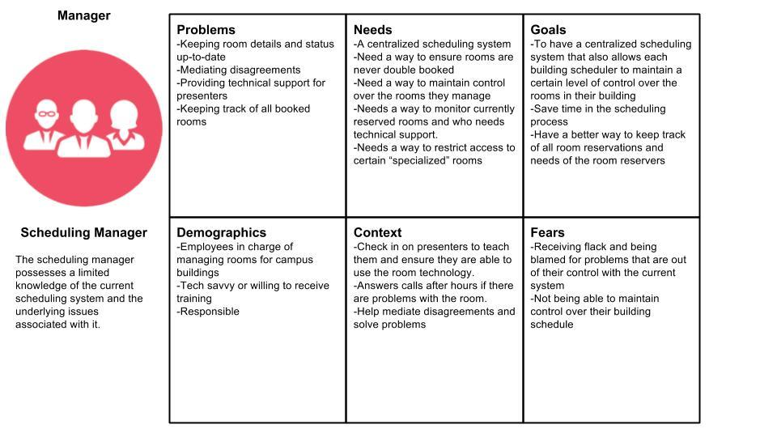

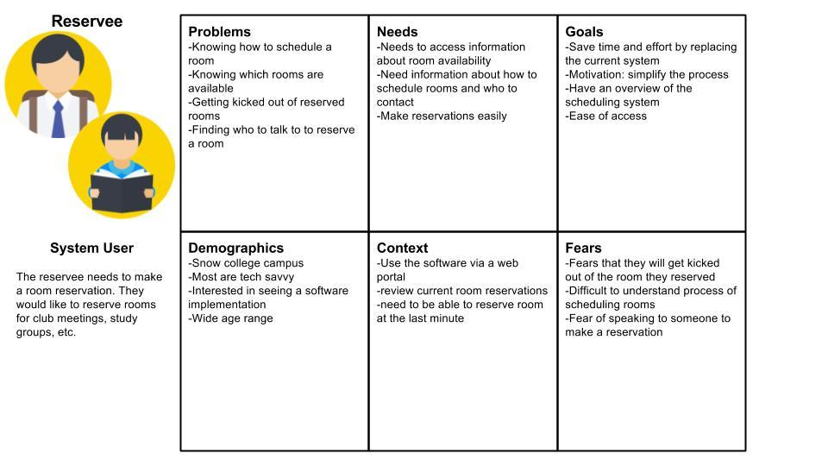

## 

## 

## Social Model

## 

# 

# 

# Usage/Flow Model

## 

## 

## Hierarchical Task Inventory Diagram

We have three different Hierarchical task inventory diagrams for our scheduler. Similar to the book, we found many work roles had mutually exclusive task sets, and therefore we created three separate HTI diagrams.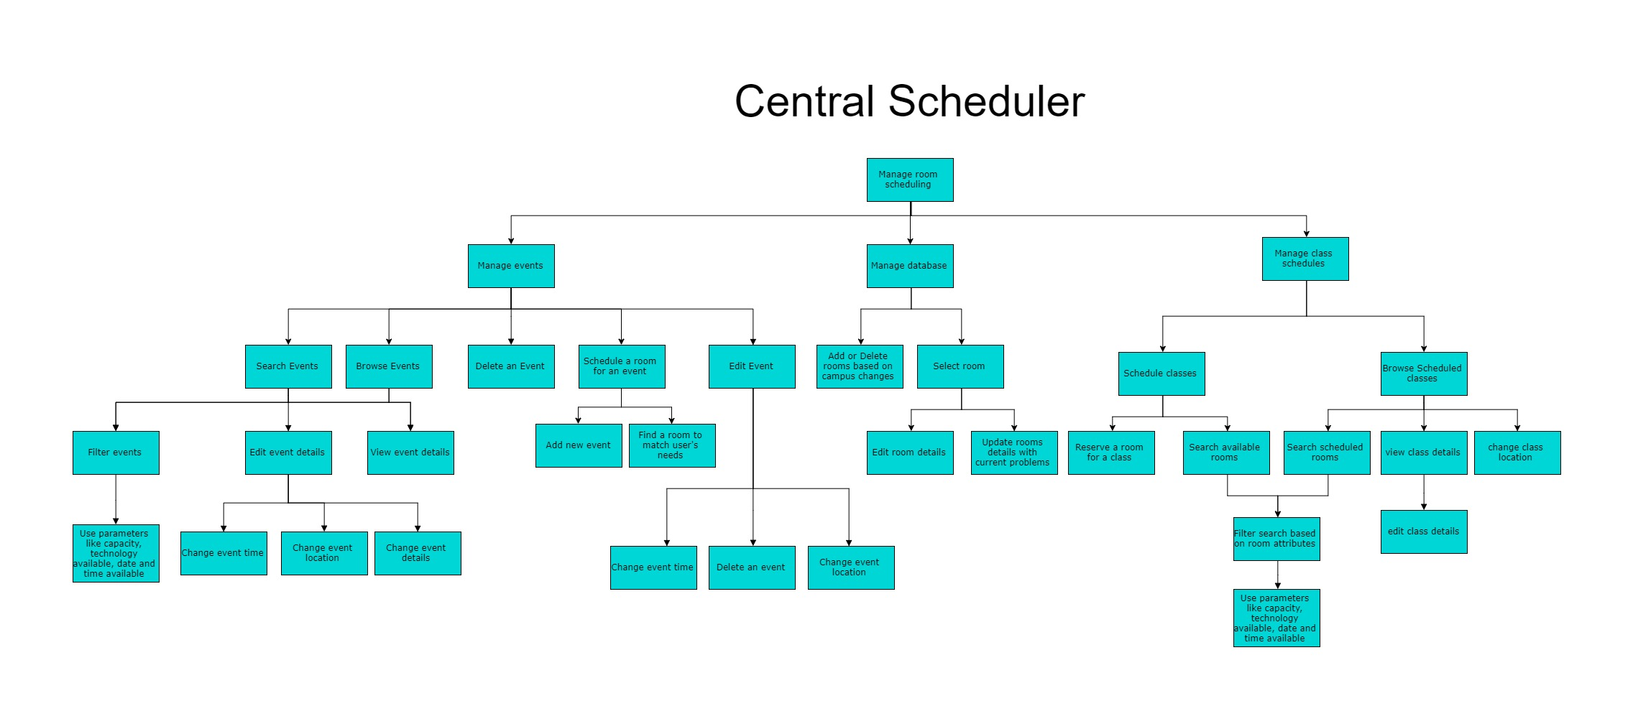

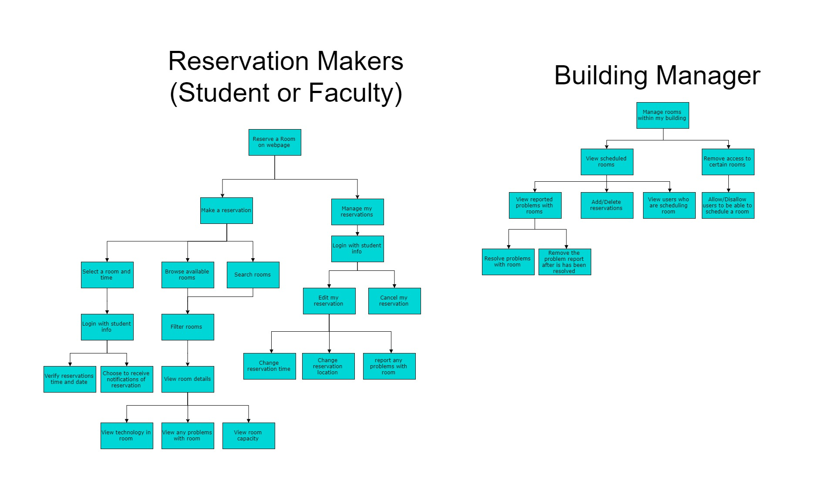

## Usage Scenarios

### Usage Scenario about a group of students using the “as is” system:

During class one day a group of students are assigned a project together. Alex and his group members plan a schedule for their group meetings and need to find a place to hold their group meetings. They agree that the library would be the best place to hold their meeting as they know there are study rooms and conference rooms available to use.

With their first meeting coming up, Alex visits the library early in an attempt to find a room suitable for a meeting with a large group of people(). The group also has certain technological requirements for the room so he has to check that each room also meets their technology needs (). He walks around the library and is able to find 3 rooms that will suit the needs of their group, unfortunately they are all occupied at the moment () and so he is unable to obtain a room for his group.

The group ended up using a small room without any of the technology they needed and it didn’t even have enough chairs for all the group members () so they had to keep the meeting short and were unable to get through the amount of material needed for that meeting.

For the next group meeting Alex wanted to be prepared by attempting to schedule a study room at the library, thinking this was a possibility. He went to the library days ahead of the next meeting and asked the front desk employee for information about how to schedule a room for a group study session. The employee didn’t have information about how to schedule a room (), but they were able to lead Alex to a manager who did know about room scheduling. The library room manager told Alex that there was no system setup () for the study rooms in the library, they were first-come first-served, but if he wanted to schedule a conference room he could work with the manager to find a time that would work for their group. Alex contacted his group members and found a time that would work for them all, then he returned to the room manager at the library to try and schedule a room at that time. Unfortunately there were no available conference rooms at that time. Alex had to communicate back and forth between his team members and the library manager many times () before he was able to schedule a room that fits his group’s needs. The group is happy but Alex leaves with a feeling that there has to be a better way to schedule a room.

## 

## 

### Envisioned Usage scenario for Simplified Sckhaedgeuler

During class one day a group of students are assigned a project together. Alex and his group members plan a schedule for their group meetings and need to find a place to hold their group meetings. They agree that the library would be the best place to hold their meeting as they know there are study rooms and conference rooms available to use.

While the group is discussing which time works best for meeting each week, Alex pulls up the Simplified Sckhaedgeuler web page and begins a search to find all the room on campus that will fit his group's needs. Alex is able to filter his search according to rooms that hold a capacity of at least 8 people and also contain the technology their group will need for their study session. He comes up with a short list of 4 different rooms across campus that fit his description. He is able to click on each room and view the schedule for each. He presents this information to the group and right away they are able to schedule a room that matches their needs. They are able to schedule the room once a week on tuesday nights, for a total of 3 weeks. The group, now having a solid room reservation, is able to begin working on their project without any problems.

# 

# 

# Work Environment Models

## Artifact Model

Because our system does not contain many physical artifacts, the Artifact Model contains few ‘physical ’artifacts and is very similar to the flow model, however it does provide a unique perspective.

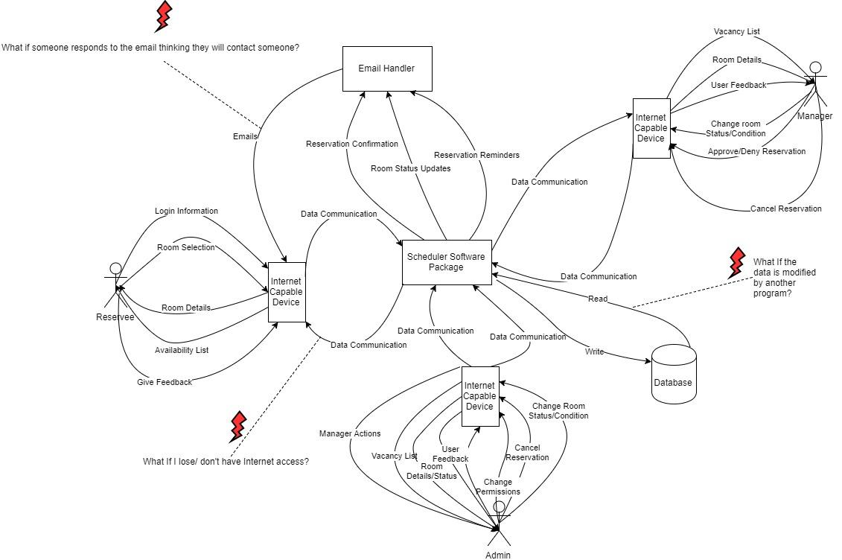

Barrier Summary

|  |  |  |
| --- | --- | --- |
| **Trigger** | **Goal** | **Barrier** |
| Room is reserved by someone | Find a room that is suitable | Room is not suitable for our needs |
| Rooms are all taken | Find a room that is available | There are no rooms available when we need one. |
| Room scheduling is a process done by few select people | Be able to schedule my own room | There is no information about how to schedule a room |
| The process of scheduling a room has many steps | Make the process more simple | There are many steps to go through to make a reservation |
| I cannot pick a room that fits my needs | Have the ability to pick a room based on certains attributes | I am unable to pick the room, so it may or may not fit my needs |
| I cannot reserve a room if I have no internet access | Provide other ways to reserve a room | No internet access available |
| I forget to check my email for notifications | Provide other ways of notifying users. | Notification email is responded to but no one is checking that inbox |
| Database is not up to date with new changes | Update database with any changes made to the system | Database data is modified by other software |
| Class needs to be scheduled for the future in a room that has been reserved for the future | Override reservation and notify System User | Events may already be scheduled in a classroom when making class schedule |
| Power is lost, database needs updating, database is corrupted | Get services up and running as quickly as possible | Server or database is down/under repair |
| Class or event needs a specific location that is already reserved | Override reservation and notify System User | Class/event needs a specific location |